Assistive Technology Team Therapy Outcome Measures
May 2009

Background.
The “Therapy Outcome Measure” (TOM) has been used by the team since February 2008 following an initial presentation at RAATE December 2007 by Pam Enderby. The tool allows therapists to describe the relative abilities and difficulties of a patient/client in the four domains of;
Impairment, Activity, Participation and Well being.

It was agreed that this would be a useful tool to use for the following reasons
- It can be used by all members of the multi disciplinary team.
- It can be used for children and adults.
- It has a strong evidence base and has been rigorously tested for reliability and clinical validity.
- It is relatively quick to use and requires minimal training.
- The tool is being used by other Assistive Technology Teams and would therefore be useful to compare outcomes for the purpose of internal or external benchmarking.

Prior to introduction of the tool team members read the manual “Therapy Outcome Measures For Rehabilitation Professionals”. The team met and practised scoring a small number of existing clients using the published rating scales. It was agreed that there was concurrence and agreement of scores (generally within 0.5 points on rating scales).

Fig 1. Table to show Therapy Outcome Measures for 23 Clients.

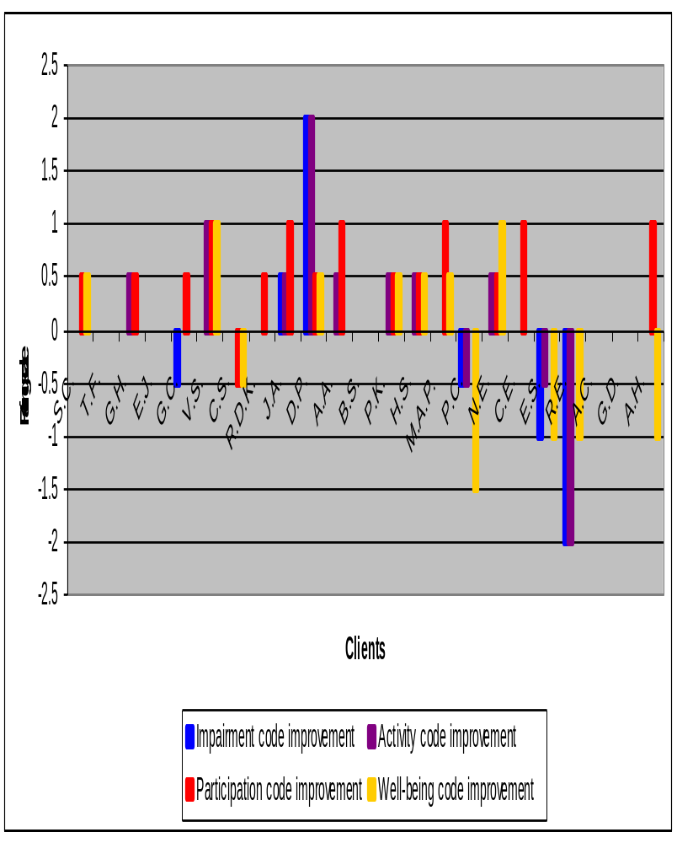
Issues and challenges using TOMS.
- Time for all members of team to discuss and complete the recording sheets.
- Not suitable for some clients who may only be seen once.
- Some clients are seen for a short assessment period e.g. 3 visits over 2 months. For some clients this would not be sufficient time to see significant change.
- Some clients seen for lengthy intervention and assessment due to changing needs. They are not discharged and there is no end to an episode of care.
- Change may not be sustained and therefore can fee like “snapshot” at time of discharge.
- For some clients goals were achieved but there were no changes in the domains. For example ;

G.M, a gentleman with a diagnosis of stroke and severe verbal dyspraxia. His goal was to explore whether any communication aid could support his communication using the phone. Following assessment and trial of a communication aid he identified that there wasn’t a suitable device and that his current skills were adequate. There was no change in his rating scores, but his therapist reported that his attitude had changed and that he was more accepting of his communication difficulties. He stopped requesting impairment based therapy, which had been unsuccessful.

- Some clients presented as very variable so they may have rated higher/lower scores at discharge but possibly not sustained long term. This may be particularly with some clients with traumatic brain injury or stroke. For example;

P.C. A woman with a diagnosis of stroke and severe dysphasia. She made significant progress during the assessment and regained some speech. However at the point of discharge she was depressed and very anxious about her move from her care home to a new home. This had a significant impact on her discharge score.

Advantages for the AT Team.
- It helps therapists consider the “big” picture and step back
- It is an indicator of change
- May help to consider timeliness of intervention/stability of client
- It highlights the very heterogeneous nature of the population
- With larger numbers it may begin to show trends or help predict outcomes for specific aetiologies
- It provides a way of considering the need to consider the balance between the benefits of technology and the stress that it can potentially bring e.g. long time to setup, not meeting client’s expectations.

Recommendations.
- More dedicated time for the team to score clients together
- More time to discuss the outcomes as a team
- Discussion with other teams e.g. Charing Cross to share findings consider evidence base
- Consider how to measure goal achievement
- Consider need to end an episode of care and not keep clients on caseload indefinitely
- Develop user questionnaire as another means to evaluate team effectiveness
- Report and present findings to other services at Bowley Close.

